PROJECT ON

ONLINE GIFT SHOP



**MADE BY**

RUSHIKESH SANJAY SHINDE

SUJAL ANAND SORE



**KarmaveerKakasahebWagh Education Society’s**

**K. K. Wagh Arts Commerce, Science, & Computer Science Colleg­e**

**Saraswati Nagar Nashik-422003**

**C E R T I F I C A T E**

This is to certify that,

**Mr.Rushikesh Shinde Mr.Sujal Sore**

Has satisfactory completed their project Laptop shop Management System as fulfillment in **B.Sc. (Comp Sci)** Department for the academic year **2022-2023**

Prof. Bendale A.H. Prof.Pavan Malani. ( H.O.D. ) (Project Guide)

Internal Examiner External Examiner

ACKNOWLEDGEMENT

We own our sincere gratitude to all those people who have given us their constant support and encouragement without which our project report would have not reached this stage.

We would like to express our thanks to Prof.PawanMalani sir for his advice and encouragement .He has been pillar of strength right through the project till the preparation of this report and helped by boosting moral,so we could surmount the difficulties that came across during completion of this project.

We would like to express our gratitude to Dr.V.M.Sewlikar , Principal,

K.K.WaghArts,Commerce,Science and Computer Science College. And Prof.Bendale.A.H Head of Computer department for the support and the infrastructure they have provide ,so that we could successfully complete the project on time.

Last but not the least we would like to express our sincere thanks to all staff members and our friends for their help and cooperation in all phases of the project .

1.Rutuja Metkar.

2.Shruti Metkar.

INDEX

|  |  |  |
| --- | --- | --- |
| Sr.No | Title | Page no. |
| 1. | Problem Defination. | 4 |
| 2. | Existing System. | 5 |
| 3. | Proposed System. | 6 |
| 4. | Requiredment Analysis. | 7 |
| 5. | Scope of the system. | 8 |
| 6. | Feasibility study. | 9 |
| 7. | H/W and S/W requiredment. | 10 |
| 8. | ERD | 11 |
| 9. | UML Diagram. | 13 |
| 10. | Data Dictionary . | 19 |
| 11. | Sample I/O Screen. | 22 |
| 12. | Conclusion. | 34 |
| 13. | Future Enhancement. | 35 |
| 14. | Bibilography. | 36 |

PROBLEM DEFINATION

As this site provides all needs related to all types of gifting items,customer can look up the site for the desired product , check its description and decide whether to purchase it or not just by clicking a finger.

The problem in existing system is that it may consume much cost and time . The Graphics User Interface(GUI) based system saves time and money and provides customers with much more options to choose from . Customers have to visit the website , view the options ,and select their desired item and login to purchase it . The desired item will be delivered at the buyer’s doorstop.

­­­­

­­­­­

EXISTING SYSTEM

The existing system of gift shopping requires lots of time. It also requires customers to visit shop and spend hours on selection and much more to find the right price.

On the seller’s side , he has to employ skilled people to handle sales and accounts which requires lots of investment .Along with it ,other expenses like maintenance, bills and shop’s rent increase the shop keeper’s expenses.

PROPOSED SYSTEM

The proposed system overcomes all problems of existing system.The customer gets to choose all items from their homes and purchase whatever they like from wide range of choices. The same items are available at different prices since the sellers are different .

The GUI provides an interesting interface for the customers. This system save time as well as money .

On seller’s side it saves money spent on infrastructure and other maintenance costs.

REQUIREMENT ANALYSIS

As we have entered into the new century the need of world is also changing . Today there is retention of the organization towards time consuming towards time consuming works. All the Organization want to save time and hence for that they are ready to do any changes in their system. As a result computer has become need of the Software In this fast life .It has become important and integral part of human life as it saves money and most important time .

The Web-Site is helpful for all users. The users chooses the item he/she wants to gift and it is delivered at their doorstep . He/she can choose the quality and get the bill generated automatically.

SCOPE OF THE SYSTEM

* System security is password dependent ,if secrecy about password information is not maintained , system could be in great danger.
* System can’t provide validity to system printed papers as in manual system signed & stamped papers have.
* System demands certain amount of information to complete particular operation ; if that information is not available then system won’t be able to complete that operation ,creating inconvenience to user.
* System requires electricity to function ,absence may result in chaotic situation in an organizational procedures.
* If system is not protected from computer viruses , infection may result in permanent data loss or total system failure which may cause extensive damage to the organization .
* Your system may become obsolete as in computer industry, technological developments are very fast , creating problems in data exchange.

FEASIBILITY STUDY

1.Technical Feasibility :

The proposed system is technically fesible since it uses less memory and accommodates more data . The software can operate on any Operating System with internet connection.

2. EconomicalFeasibility:

In this case , costs incurred on an internet connection and computer are overhead but since almost every house has a computer or tablet and internet connection so it is not much of a problem .

3. Operational Feasibility :

The system effectively handles the load of multiple requests.The system does not crash under tremendous pressure.

HARDWARE AndSOFTWARE REQUIREMENT

* Hardware requirement(minimum) :

Processor : Intel P4 based system.

RAM : 250MB or higher.

Hard-disk : Minimum 2GB

* Software requirement:

Operating System : Windows or Ubuntu

Front end : PHP,JAVASCRIPT,HTML

Back end : MYSQl

**ER DIAGRAMS**

**ADMIN SIDE**

MANAGES

1 M

ADMIN

PRODUCTS

M

HAVE

M

CATEGORIES

**USER SIDE**

has

GIFT SHOP

1 1 M

Visited to

M

CATEGORIES

buys

M M

CUSTOMER

have

M

M

pay

PRODUCTS

M

Added to

M

BILL

M

CART

**UML DIAGRAMS:- CLASS DIAGRAM**

1 *

CATEGORY

#cat_id:int

+cat_name:varchar(20)

#addcat():void

#deletecat():void

#updatecat():void

ADMIN

-id :int

-password :varchar(10)

-add():void

-delete():void

-orderdetails():void

-custdetails():void

1

*

* *

CUSTOMER

#cusid:int

+cusname:varchar(20)

#addcust():void

#deletecust():void

#updatecust():void

PRODUCT

#pid:int

+pname:varchar(20)

+price:numeric(5,0)

#addprod():void

#updateprod():void

#deleteprod():void

* *

UNREGISTERED

#crname:varchar

#mobno:numeric(10,0)

#email:varchar(20)

#pass:varchar(10)

#add():void

#delete():void

REGISTERED

#custid:int

#shoppingid:int

#email:varchar(20)

#password:varchar(10)

#update():void

#delete():void

#delete():int

**USECASE DIAGRAM**

<<i>>

<<i>>

Gift shop

**<<**

**<,,,<<<,<,<<<i,,,,,<<<<<**

**P**

<User**><**Admin>

**Gift shop**

**SEQUENCE DIAGRAM**

ADMIN

GIFT SHOP

CUSTOMER

1.Visits Gift Shop

2.provides product option

3.Orders products

4.passes selection to

Admin site

5.Provides information

page

6.Registration process

7.Fill in details and

Select payment option

. 8.Provides customer

And payment details

9.Confirm order

10.provide receipt

X X X

**COLLABORATION DIAGRAM**

7:Fill in deatails& Select payment option.

3:Orders products.

1:Visits site.

GIFT SHOP

CUSTOMER

2:Provide Product 5:Provides

6.Registration Page registration

page

10:Provide Receipt

9:Confirms

4:Passes Selection. Order &

8:Provide Payments provide

& Customer details receipt

ADMIN

**Data Dictionary**

**Adminmaster:**

|  |  |  |
| --- | --- | --- |
| Field Name | Datatype | Constraint |
| Adminid | Int(11) | Primary key |
| Username | varchar(255) | ---- |
| Password | varchar(255) | ---- |

**Categorymaster:**

|  |  |  |  |
| --- | --- | --- | --- |
| Field Name | Datatype | | Constraint |
| Categoryid | Int(11) | | Primary key |
| Categoryname | varchar(255) | | ---- |
| **Orderdetails:** |  | | |
| Field Name | Datatype | Constraint | |
| Detailsid | Int(11) | Primary key | |
| Productid | Int(11) | --- | |
| Quantity | Binary(11) | --- | |
| Rate | Decimal(10,0) | --- | |
| Amount | Decimal(10,0) | --- | |
| Orderid | Int(11) | Foreign key | |

**Ordermaster:**

|  |  |  |
| --- | --- | --- |
| Field Name | Datatype | Constraint |
| Orderid | Auto increment | Primary key |
| Orderdate | Datetime | ---- |
| Membername | Varchar(250) | ---- |
| Address | Varchar(250) | ---- |
| Email | Varchar(250) | ---- |
| Cardno | Varchar(250) | ---- |
| Mobileno | Varchar(250) | ---- |
| Netamount | Varchar(500) | ---- |

**Product:**

|  |  |  |
| --- | --- | --- |
| Field Name | Datatype | Constraint |
| Productno | Int(11) | Primary key |
| Product | Varchar(50) | ---- |
| Price | Decimal(10,0) | ---- |
| Desc | Text | ---- |
| Imagn | Varchar(50) | ---- |

**Productmaster:**

|  |  |  |
| --- | --- | --- |
| Field Name | Datatype | Constraint |
| Productid | Int(11) | Primary key |
| Productname | Varchar(250) | ---- |
| Rate | Decimal(10,0) | ---- |
| Description | Text | ---- |
| Imagename | Varchar(250) | ---- |
| Categoryid | Int(11) | Foreign key |

**Shoppingmaster:**

|  |  |  |
| --- | --- | --- |
| Field Name | Datatype | Constraint |
| Shoppingid | Int(11) | Primary key |
| Productid | Int(11) | Foreign key |
| Quality | Int(11) | ---- |
| Sessionid | Varchar(255) | ---- |

**Bill Table:**

|  |  |  |
| --- | --- | --- |
| Field Name | Datatype | Constraint |
| Bill No. | Int(55) | Primary Key |
| Name | Varchar(25) | --- |
| BillDate | date | --- |
| Address | Varchar(25) | --- |
| Email | Varchar(25) | --- |
| MobileNo | Int(10) | --- |
| ProductName | Varchar(25) | --- |
| Rate | Int(55) | --- |
| Quantity | Int(55) | --- |
| Amount | Int(55) | --- |
| NetAmount | Int(55) | --- |

**I/0 SCREENS**

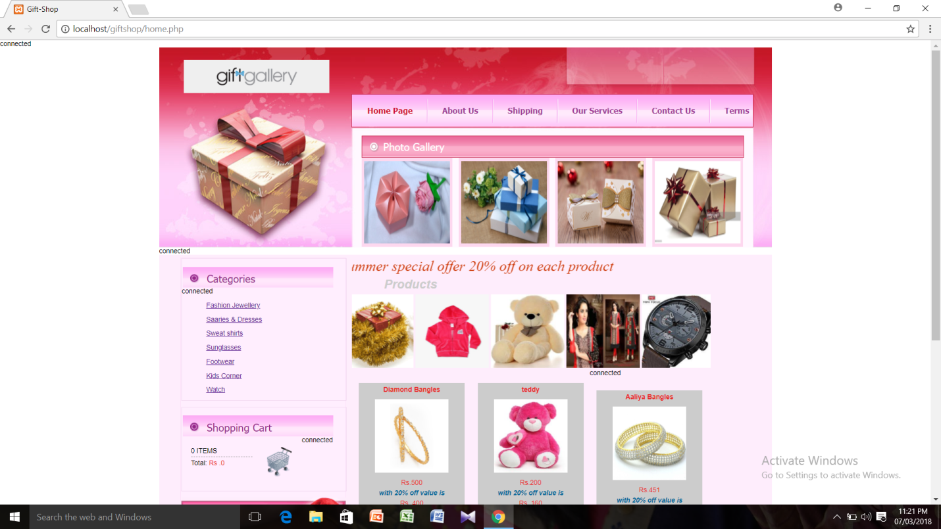

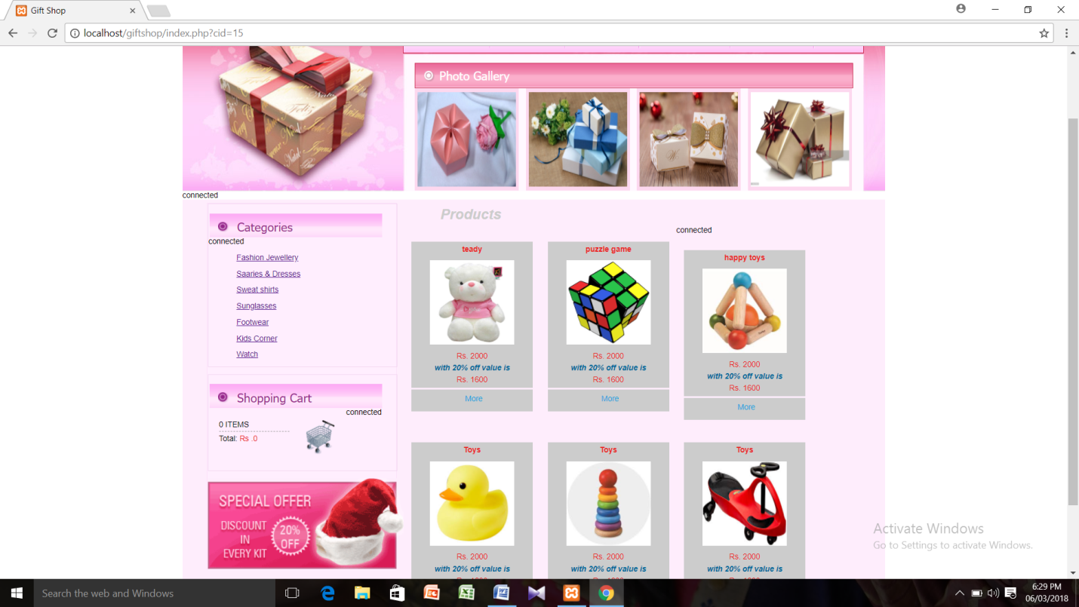

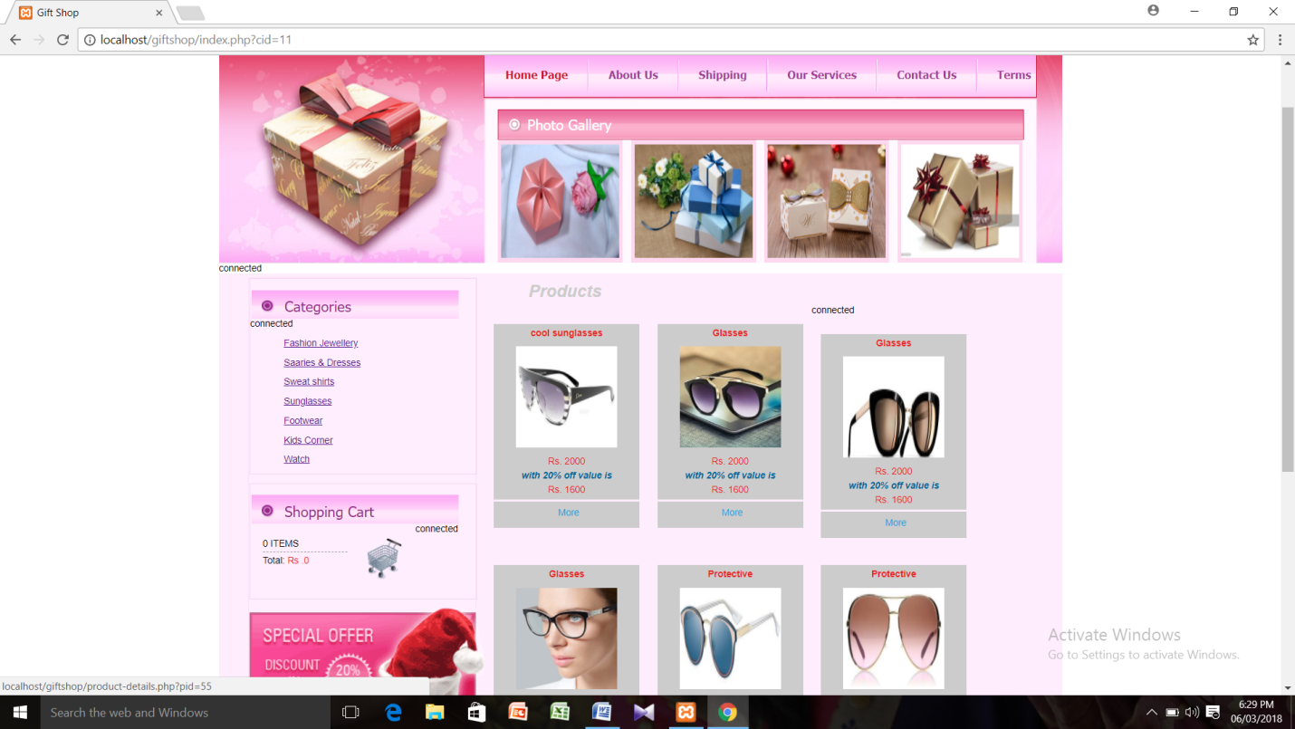

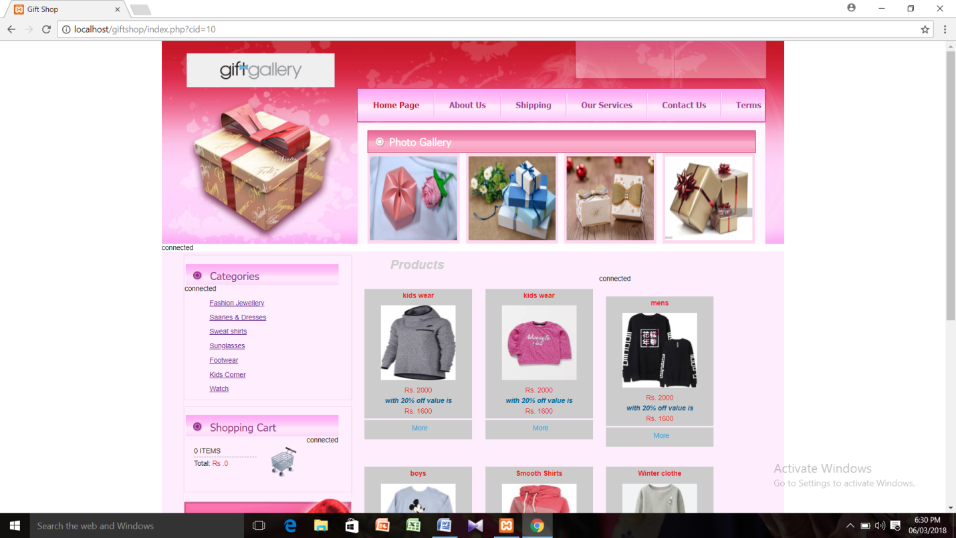

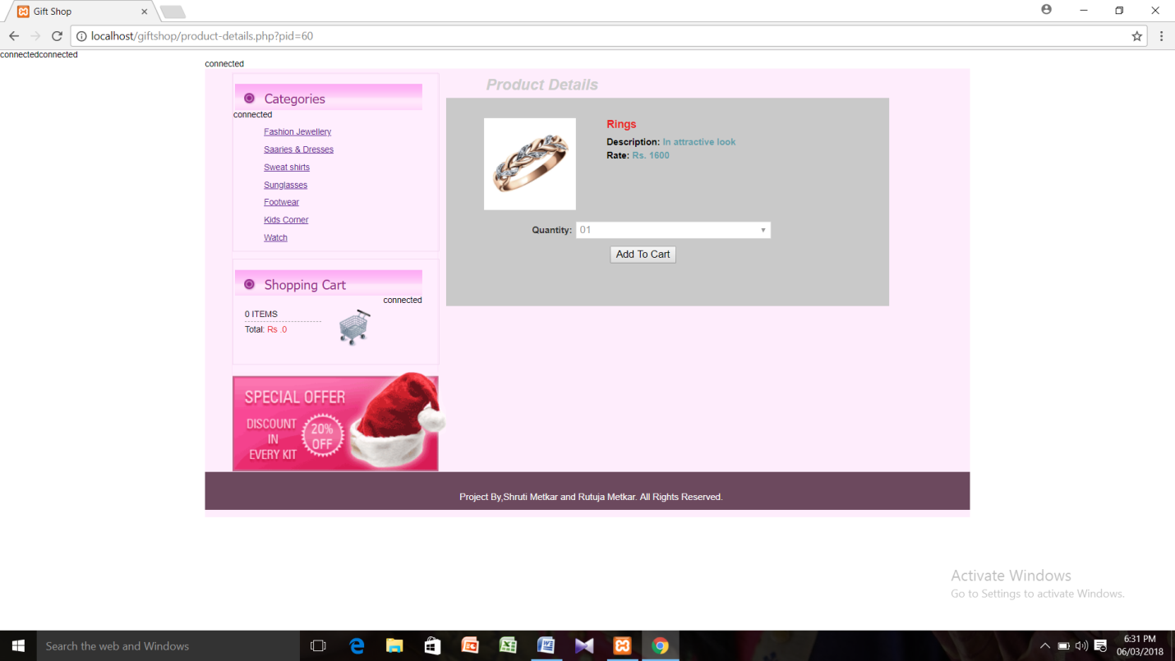

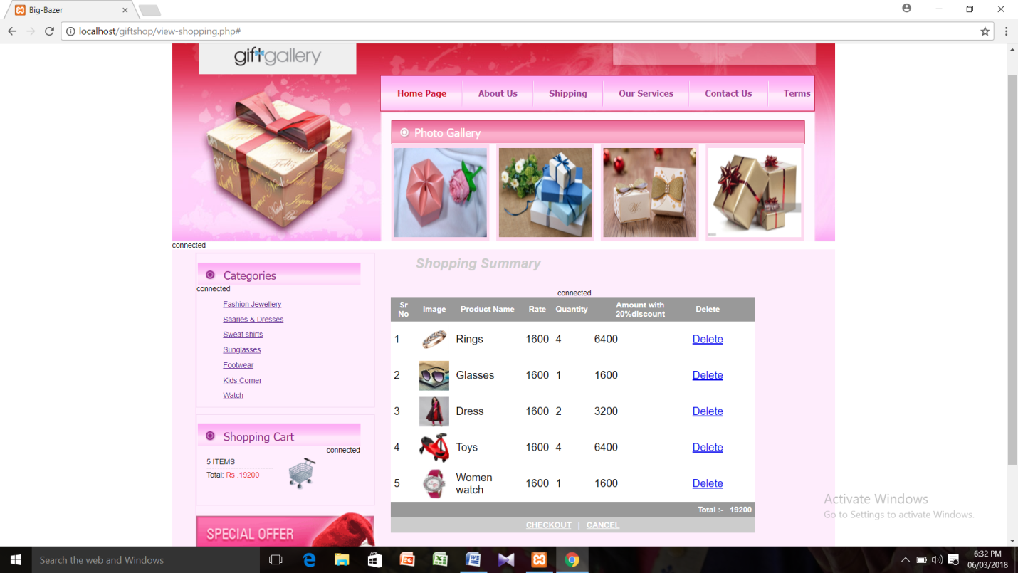

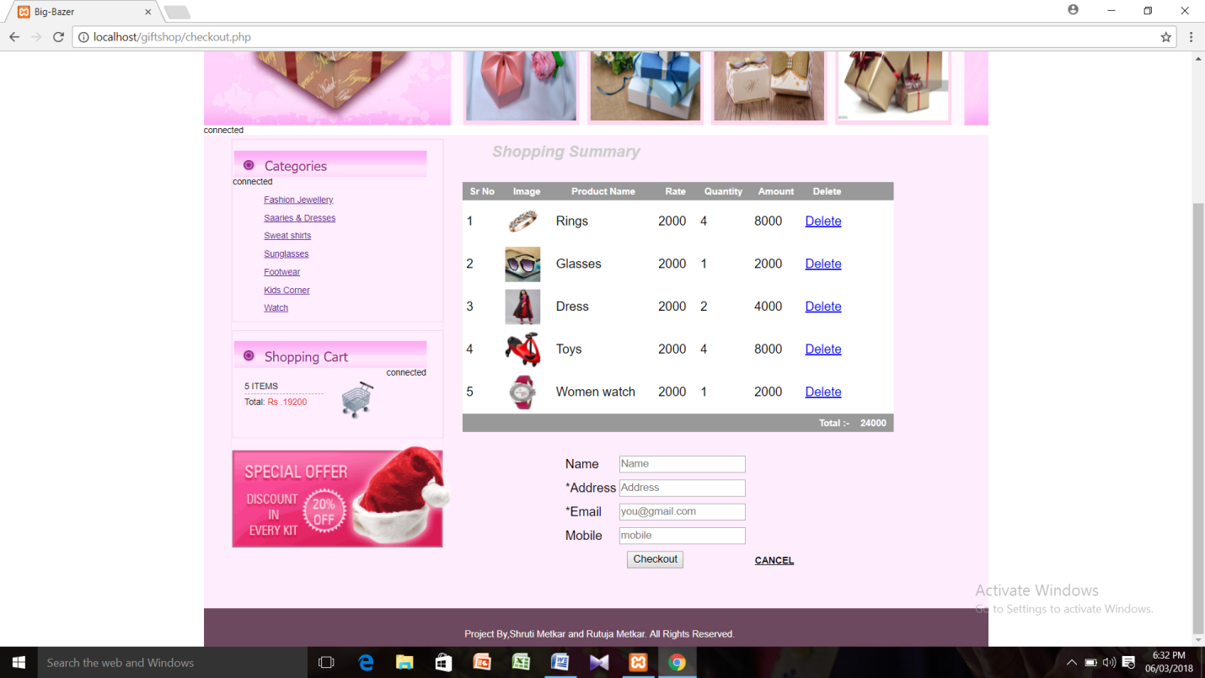

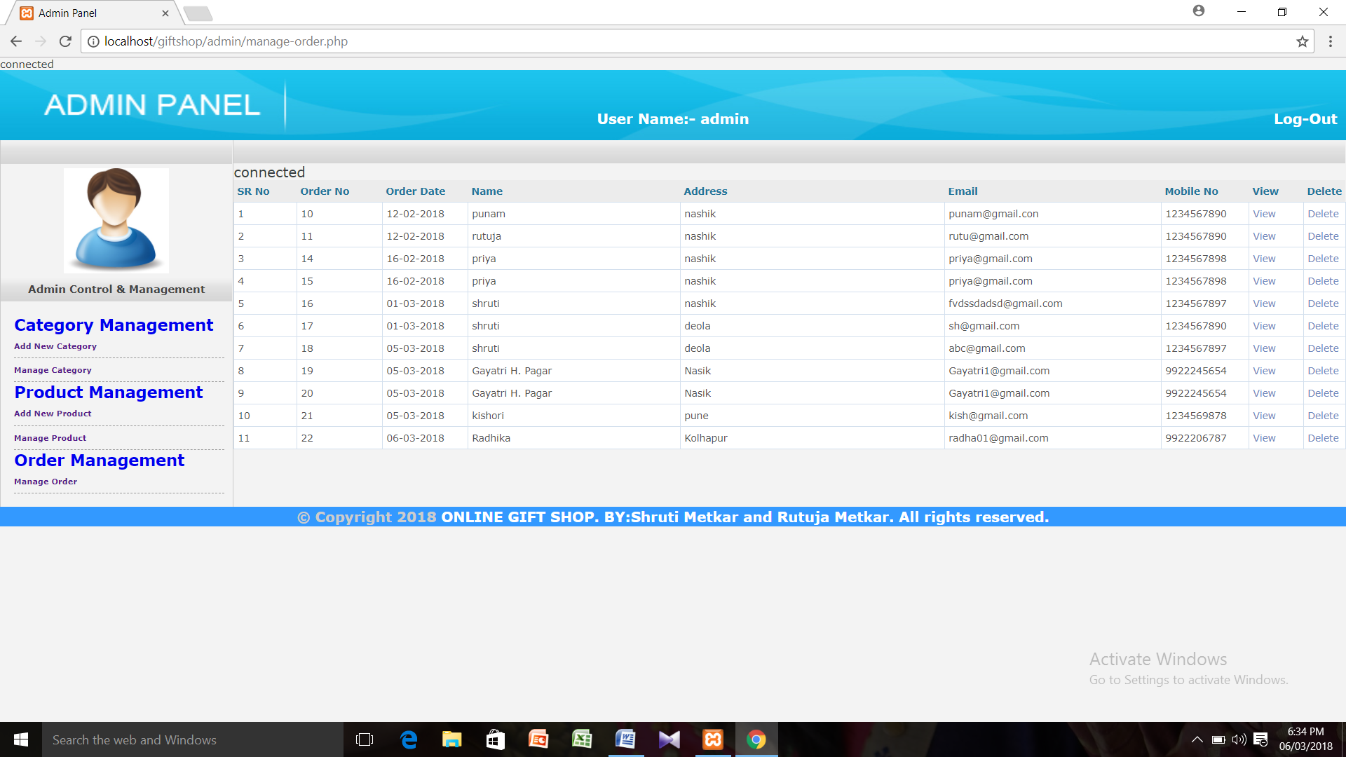

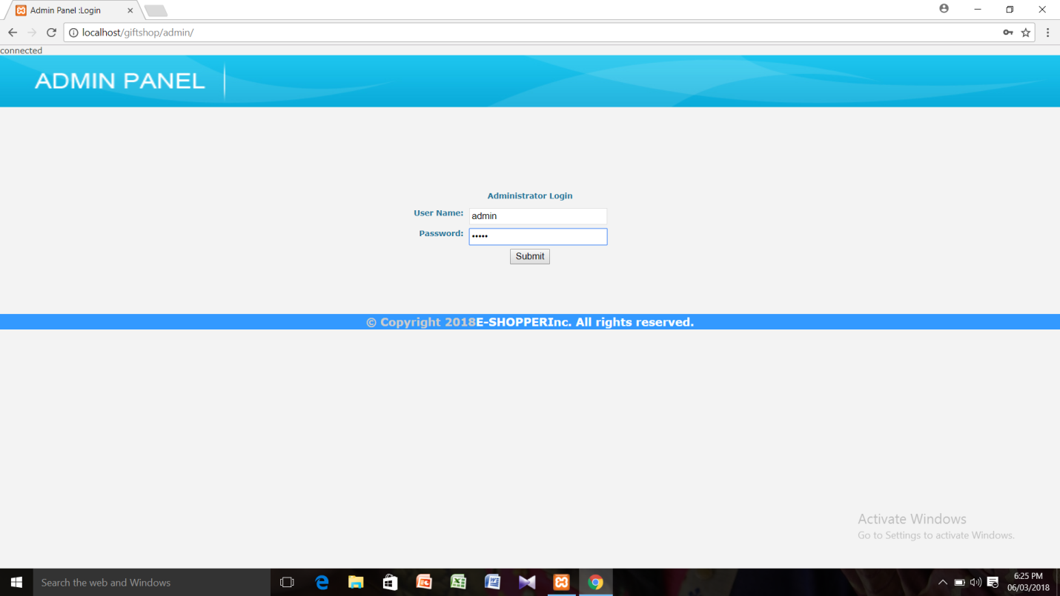

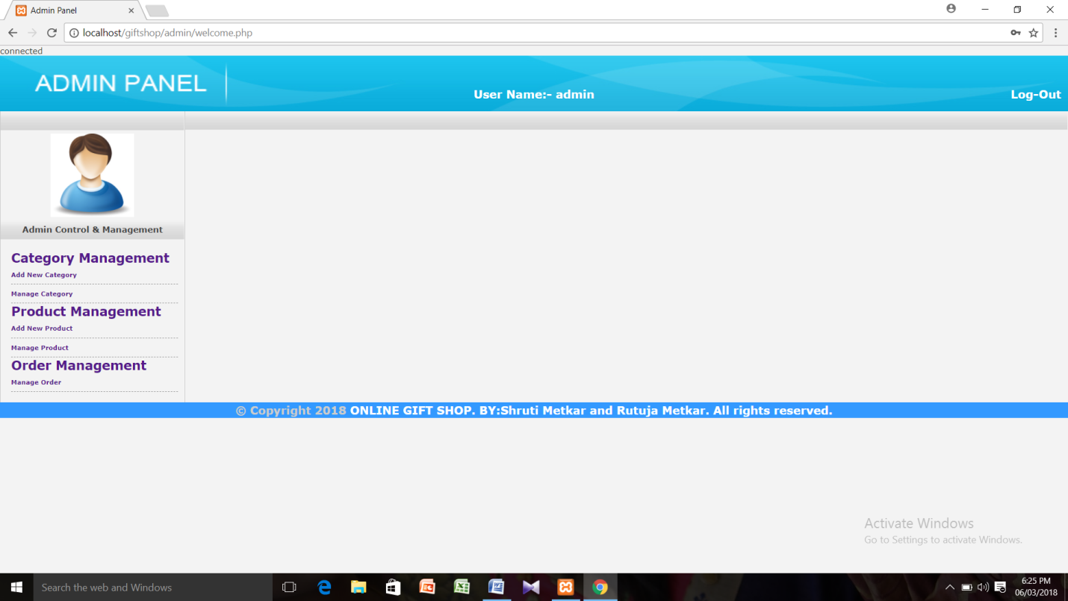

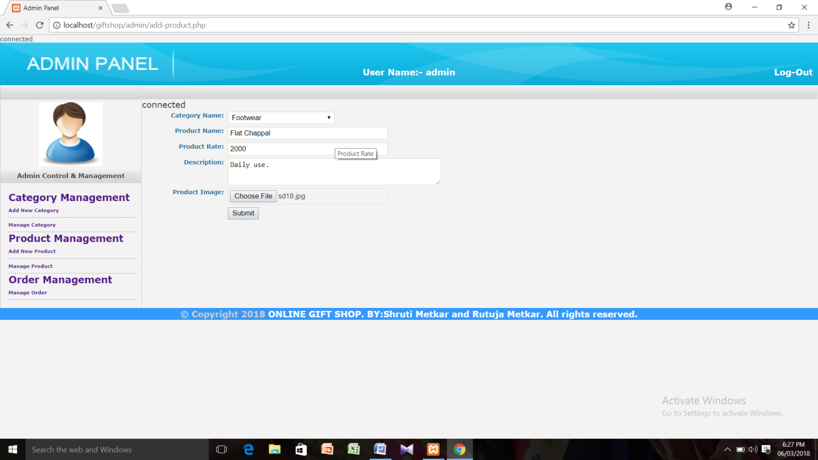

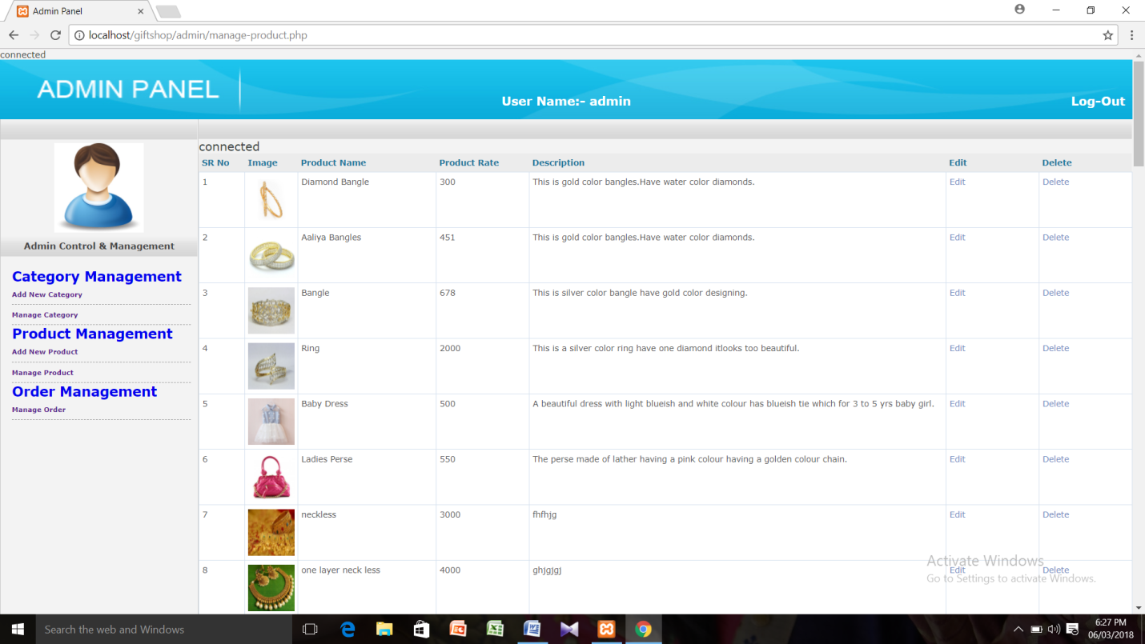

s

**CONCLUSION**

It is user friendly interface which will help the organization to contribute to perform the task more easily.

In this system for the records of many customers , We have also provided Validation to all fields is form based on their data types in database . We provide all information about products.

We are providing hyperlinks to words like home , about us , Contact us so that user can use it like shortcuts . All records are correctly save in database so there is no chance of ambiguity.

Relationships of tables are well maintained.

**FUTURE ENHANCEMENT**

The system has been developed with the at most care and keeping in mind that exact needs of the user .But still due to shortest of time some features couldn’t be added . This few feature will be act as future enhancement in system.

1) To provides multiuser environment .

2) To make every information available to user.

3) As much as easy searching without affecting internet internet speed.

4) Internet banking feature.

BIBILOGRAPHY

Books :

HTML fourth edition – By Wendy Willard

PHP4 – By Ganesh Prasad

Web Development & PHP Programming – By Mrs. NeelimaPadmawar.

THANK YOU